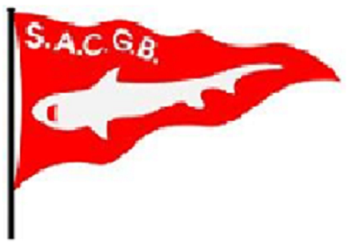

STANDING ORDER – SACGB Subs

MEMBERSHIP NUMBER

Name;

Telephone no. ___________________ (daytime) ___________________ (evening)

Postal address;

email address:

I/we understand that the completed Standing Order Mandate has been forwarded to the bank indicated and that £25 will be taken from my/our account on the first of January annually via Standing Order and paid into the Shark Angling Club of Great Britain account until I/we advise the bank otherwise.

I/we agree that if we wish to cancel this order I/we will also inform S.A.C.G.B of this decision.

Signature_______________________________

Date:________________

STANDING ORDER MANDATE
YOUR DETAILS:

Full Name:
Address:
Postcode:

Bank Name
Bank Address
Postcode
Sort Code No: Your Account Number

PLEASE PAY:

Recipients name
Shark Angling Club of Great Britain

Recipients bank and branch name
Lloyds Bank

Recipients Sort Code No. Recipients Account No.
30-95-08 00692083

Date of first regular payment Amount and frequency thereafter
01 | 01 | ……….
£25 Annually

Payment Reference (Initial and Surname)
SACGB: …………………

Until further notice in writing

Signature_______________________________

Date:________________

